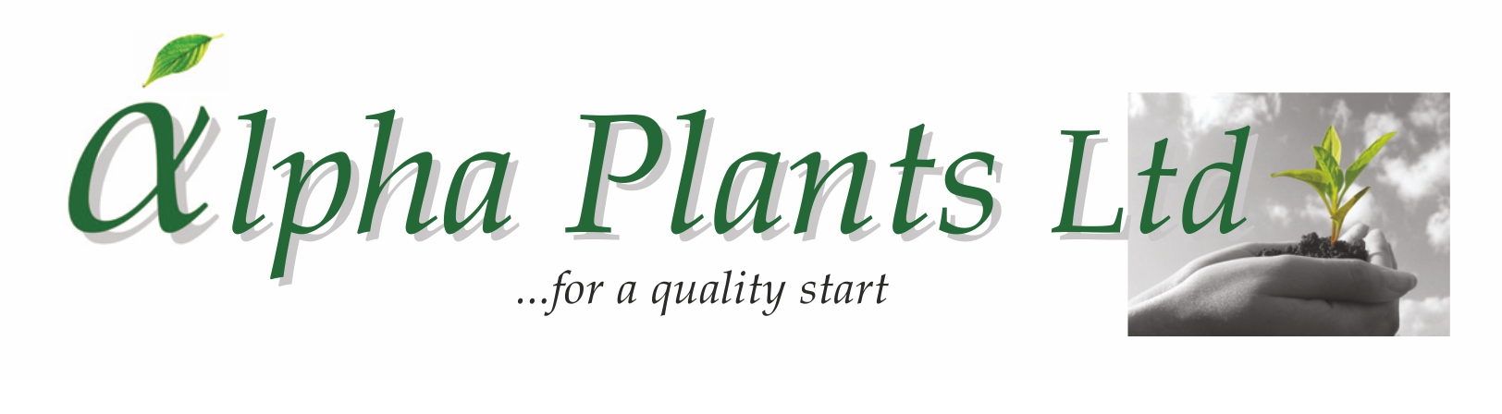
Herb Plug Availability

for Delivery

Wks 8 to 24, 2025

Company Name………………………………………………………………………………………………………

Address…………………………………………………………………………………………………………………...

………………………………………………………………………………………………………………………………………………………………………….

………………………………………………………………………………………………………………………………..

VAT Number…………………………………………... Purchase Order Number………………………………

Contact Name …………………………………………. Phone Number …………………………………….

Email Address ……………………………………………………………………………………………………………

Delivery Address (if Different) …………………………………………………………………………………………...

………………………………………………………………………………………………………………………………..

...................................................................................................................................................................................................

How to Order:

- Complete Company name and address details together with required delivery week.

- Complete the number of trays required by variety. Sold as 100 trays. Prices are quoted ex VAT, ex nursery and do not include transport. Transport will be quoted separately where required.

- Send your order back to us either by Email: enquiries@alphaplants.co.uk or by post to
Alpha Plants Ltd, Millview Nurseries, Fengate Road, West Pinchbeck, Spalding, Lincolnshire PE11 3NE.

4) Any questions, please call us on (01775) 640150 or Email: enquiries@alphaplants.co.uk

VAT Registration Number: 367 6849 36 Plant Passport Number: GB 32470



Due to the large variety of herbs available, we cannot list them all. If you would like a variety which is not listed, please contact us for a quote.

Common Name (A-Z) | Latin Name | Cell Tray Size | Week Available from | Price per Plant | DELIVERY WEEK(s) ………………..…………….
 |  |  |  |  | Number of Trays required:
Alpine Strawberry | Fragaria vesca | 100 | 8 | 31p
Balm All Gold | Melissa officinalis ‘All Gold’ | 100 | 8 | 31p
Balm variegated | Melissa officinalis ‘Variegata’ | 100 | 8 | 31p
Chamomile Flore Pleno | Chaemaemelum nobile ‘Flore Pleno’ | 100 | 8 | 33.5p
Chamomile Sweet | Chaemaemelum noblis | 100 | 8 | 31p
Chamomile Treneague | Chaemaemelum nobile ‘Treneague’ | 100 | 8 | 33.5p
Coriander | Coriandrum sativum ‘Santos’ | 100 | 8 | 31p
Curry | Helichrysum angustifolium | 100 | 8 | 33p
Curry Dwarf | Helichrysum Italicum Dwarf | 100 | 8 | 33p
Dill | Anethum graveolens ‘Diana’ | 100 | 8 | 31p
Fennel Bronze | Foeniculum vulgare ‘Purpureum’ | 100 | 8 | 33p
Fennel Common | Foeniculum vulgare | 100 | 8 | 33p
Feverfew Gold | Tanacetum parthenium 'Aureum' | 100 | 8 | 31p
French Tarragon | Artemisia dracunculus | 84 | 8 | 36p
Marjoram Gold Tipped | Origanum vulgare 'Variegatum' | 100 | 8 | 31p
Mint After Eight | Mentha x piperita ‘After Eight’ | 100 | 8 | 31p
Mint Apple | Mentha suaveolens ‘Apple Mint’ | 100 | 8 | 31p
Mint Chocolate | Mentha x piperita f. citrata ‘Chocolate’ | 100 | 8 | 31p
Mint Lemon | Mentha spp. ‘Lemon’ | 100 | 8 | 31p
Mint Indian | Satureja douglasii | 100 | 8 | 33p + 2.8p R
Mint Moroccan | Mentha spicata ‘Moroccan’ | 100 | 8 | 31p
Mint Orange | Mentha x piperita f. citrata ‘Orange’ | 100 | 8 | 31p
Mint Peppermint (Black) | Mentha x piperita | 100 | 8 | 31p
Mint Spearmint (Garden Mint) | Mentha spicata | 100 | 8 | 31p
Mint Strawberry | Mentha x piperita ‘Strawberry’ | 100 | 8 | 31p
Mushroom Plant | Rungia klossii | 100 | 8 | 31p
Ocimum (Basil) | Hybrida Blue | 100 | 18 | 31p
Oregano (Marjoram) | Origanum vulgare | 100 | 8 | 31p
Oregano Country Cream | Origanum vulgare ‘Variegated’ | 100 | 8 | 31p
Oregano Gold | Origanum vulgare ‘Gold’ | 100 | 8 | 31p
Oregano Hot ‘n’ Spicy | Origanum vulgare ‘Hot’ | 100 | 8 | 31p
Parsley Curled | Petroselinum crispum | 100 | 8 | 30p
Parsley French | Petroselinum crispum ‘Hortense’ | 100 | 8 | 30p
Parsley Giant Italian | Petroselinum neapolitanum | 100 | 8 | 30p
Rosemary | Rosmarinus officinalis Upright | 84 | 12 | 36p
Sage Golden | Salvia officinalis 'Icterina' | 100 | 8 | 33p
Sage Growers Choice | Salvia officinalis ‘Growers Choice’ | 100 | 8 | 33p
Sage Purple | Salvia officinalis 'Purpurea' | 100 | 8 | 33p
Sage Tricolour | Salvia officinalis 'Tricolour' | 100 | 8 | 33p
Sweetleaf | Stevia rebaudiana | 100 | 8 | 33p
Thyme Compact | Thymus vulgaris ‘Compact’ (Freddy) | 100 | 8 | 34p
Thyme Doone Valley | Thymus citriodorus 'Doone Valley' | 100 | 8 | 34p
Thyme Gold | Thymus vulgaris ‘Gold’ | 100 | 8 | 34p
Thyme Lemon | Thymus citriodorus | 100 | 8 | 34p
Thyme Lemon variegated | Thymus citriodorus ‘Variegated’ | 100 | 8 | 34p
Thyme Orange | Thymus Orange | 100 | 8 | 34p
Thyme Silver Queen | Thymus citriodorus 'Silver Queen' | 100 | 8 | 34p
Vietnamese Coriander | Persicaria odorata | 100 | 8 | 33p
Winter Savory | Satureja montana | 100 | 8 | 33p

